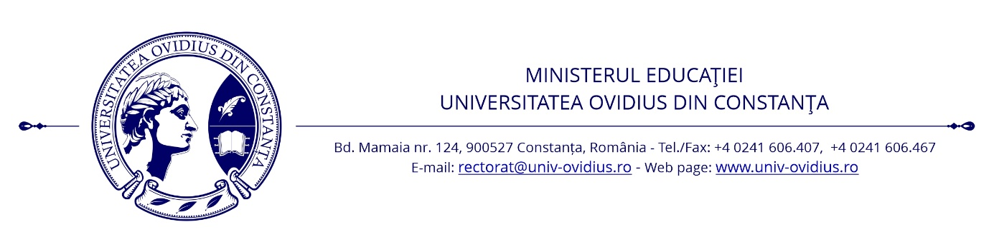
FACULTY OF LAW AND ADMINISTRATIVE SCIENCES
1 Aleea Universităţii, Constanţa E-mail: drept.secretariat@univ-ovidius.ro
Tel. +4 0241 694330 Web page: drept.univ-ovidius.ro

CALL FOR PROPOSALS

International Student Conference on Law and Administrative Sciences

Constanța, 9-10 May 2023

The International Student Conference on Law and Administrative Sciences, taking place between 9-10 May 2023, is organized by the Faculty of Law and Administrative Sciences at the Ovidius University of Constanța, in partnership with the law schools at the State University of Moldova (Kishinev, Republic of Moldova) and the Yuriy Fedkovych Chernivtsi National University (Ukraine).
Paper proposals are invited from any student enrolled in a bachelor’s or master’s degree in Law or Administrative Sciences, from any accredited law school in Romania or the partner schools in Kishinev and Chernivtsi.
There is no conference fee, but registration is required. The conference is organized as a hybrid event (in-person for authors affiliated to the host university, with virtual attendance for guest and partner law schools), and awards shall be given to the best papers in each of the four sessions.
Proposals may be submitted through the online application form available here. During registration, authors are required to provide the title, abstract and keywords of their paper. The results of the peer review will be sent out by email before 30 April 2023. Upon acceptance, the abstracts shall be included in the Book of abstracts accompanying the final program.
Papers may be presented in either Romanian or English. The timeframe for presentations may not exceed 10 minutes. Authors may use PowerPoint to enhance the delivery of their oral presentation. Depending on the topics covered by the accepted papers, session chairs may group them to hold panel debates or Q&A sessions.
Important dates:
- Deadline for registration: 24 April 2023
- Deadline for sending out notices of acceptance: 30 April 2023
- Final program before 5 May 2023

Further information:
- Criminal Sciences – Associate prof. dr. Mariana Mitra-Niță (mariana_mitra@yahoo.com)
- Private Law – Assistant prof. dr. Anthony Murphy (anthony.murphy@365.univ-ovidius.ro)
- Public Law – Associate prof. dr. Flavia Lucia Ghencea (fghencea@hotmail.com)
- Administrative Sciences – Professor dr. habil. Mihaela Rus (psiholog_m@yahoo.com)

Provisional program:

Day 1 (9.05.2023)
8³⁰-9⁰⁰ – Welcome and registration
9⁰⁰-9³⁰ – Opening Ceremony
9³⁰-10⁰⁰ – Coffee break
10⁰⁰-14⁰⁰ – Parallel sessions:
Session 1 – Criminal Sciences
Session 2 – Private Law
Session 3 – Public Law
14³⁰ – Day 1 Awards Ceremony

Day 2 (10.05.2023)
8³⁰-9⁰⁰ – Welcome and registration
9⁰⁰-9¹⁵ – Opening speech
9¹⁵-9³⁰ – Coffee break
9³⁰-14⁰⁰ – Session 4 – Administrative Sciences
14³⁰ – Day 2 Awards Ceremony

